Nik Baldis

Dr. Balan

BAN-6025

22 October 2023

Project 2: Forecasting Report

The business problem that we are looking to gain more insight into two airline companies and the likelihood of receiving a baggage claim in relation to factors such as the total number of flights scheduled, canceled, and passengers enplaned so that travel agency customers can make informed travel decisions for the first six months of 2011. I used seven years of data gathered monthly from United Airlines and American Eagle Airlines of the number of baggage claims, scheduled flights, canceled flights, and the number of passengers boarded to see if there is a correlation between the number of baggage claims and those other variables. I also created a forecasting model for the number of baggage claims and the number of canceled flights that could help to adjust travel arrangements.

The most significant factor influencing baggage claims for United Airlines and American Eagle is the number of canceled flights. Canceled flights and passengers with checked luggage will lead to opportunities for communication breakdowns. The correlation between baggage claims and canceled flights is about the same at 0.61 and 0.62 for United Airlines and American Eagle, respectively. American Eagle has a lot of difficulty in general with baggage claims, as both the number of scheduled flights and passengers enplaned have a high correlation of 0.78 for scheduled flights and 0.61 for passengers enplaned to the number of baggage claims. Figures 1 and 2 show the correlations.A screenshot of a chart
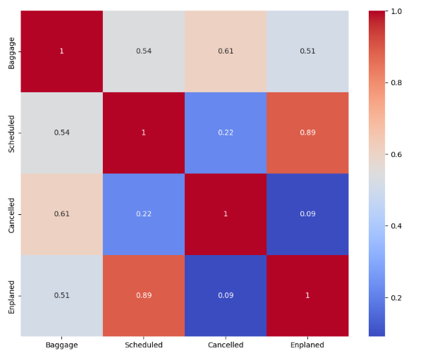1 and 2 below:

Figure 2 American Eagle Correlation

Figure 1 United Airlines Correlation

A forecasting model with a mean absolute percent error of 17.94% created the baggage claims forecast for United Airlines. A MAPE of 17.94% means that there is about an 18% error between the predicted values that the model creates and the actual data that I used. As you can see in the forecasted area of Figure 3, the model predicts that baggage claims will drop around February of 2011 to about 8,000 and rapidly increase to a high of about 20,000 baggage claims around June of 2011. The American Eagle Airlines model was very similar to the United Airlines model, with an even better MAPE of 14.71%. Figure 4 shows a very similar forecast shape to United Airlines, with a low point around February of 2011 of about 6,000 claims and a quick increase to a high of about 12,500 baggage claims in June of 2011.

Figure 4 American Eagle Airlines Baggage Claim Forecast

Figure 3 United Airlines Baggage Claim Forecast

The MAPE values for the canceled flight forecasts for United Airlines and American Eagle Airlines are average for a model, with a value of 47.8% for the United Airlines forecast and a slightly better value of 41.1% for the American Eagle forecast. However, these models are acceptable for forming travel arrangements based on trends. As one may expect based on the correlation matrices, the canceled flight forecasts follow roughly the same pattern of a low point around February or March of 2011 and a rapid increase to June of 2011. For United Airlines (Figure 5), the low end is about 0 canceled flights in March of 2011 and a high of about 250 canceled flights in June. American Eagle (Figure 6) has more predicted canceled flights, with a low point of around 500 in March and a high of about 1,100 in June.

Figure 6 American Eagle Cancelled Flights Forecast

Figure 5 United Airlines Cancelled Flights Forecast

In conclusion, United Airlines and American Eagle Airlines forecasts follow roughly the same trend of decreasing baggage claims and canceled flights around February and rapidly increasing as "vacation season" begins in June. Based on my models, passengers traveling with American Eagle have a better chance of not having baggage issues, as the model predicts American Eagle to have about 7,500 fewer baggage claims than United in June. However, passengers are more likely to have their flight canceled with American Eagle, as the model expects them to have about 850 more cancellations than United in June. I recommend traveling in February or March of 2011, as both airlines have their predicted low points for baggage claims and canceled flights.